CHAPTER 2
VISUAL DESCRIPTION OF DATA

SECTION EXERCISES
2.1 d/p/e A frequency distribution is a table that divides the data values into classes and shows the
number of observed values that fall into each class. By summarizing and reporting data into a frequency distribution, the data can be readily understood and interpreted.

2.2 d/p/m Selecting the number of classes is a subjective process. In general, about 5 to 15 classes will be suitable.

2.3 c/p/m
a. 45.59 million b. lower limit is 35, upper limit is under 45 c. 10 years d. 40 years

2.4 c/p/m
a. 40.78 million b. lower limit is 25, upper limit is under 35 c. 10 years d. 30 years

2.5 c/p/m
a. 183.53 thousand b. lower limit is 45, upper limit is under 55 c. 10 years d. 50 years

2.6 c/p/m
a. 34.23 thousand b. lower limit is 15, upper limit is under 25 c. 10 years d. 20 years

2.7 d/p/e Mutually exclusive means a given data value can fall into only one class. Exhaustive means that the set of classes includes all possible data values.

2.8 c/p/m The number of states in each category is shown above the corresponding bar. For example, there are 13 states within the $50 billion – under $100 billion category.
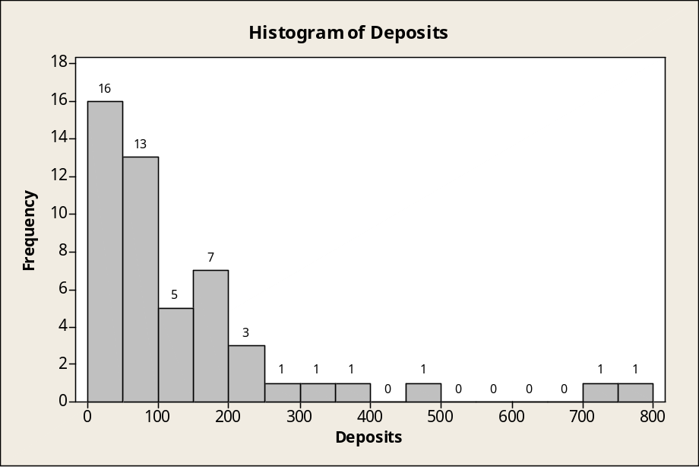

2.9 c/p/m The number of employees in each category is shown above the corresponding bar.
For example, there are 7 data values within the 20 – under 22 category.
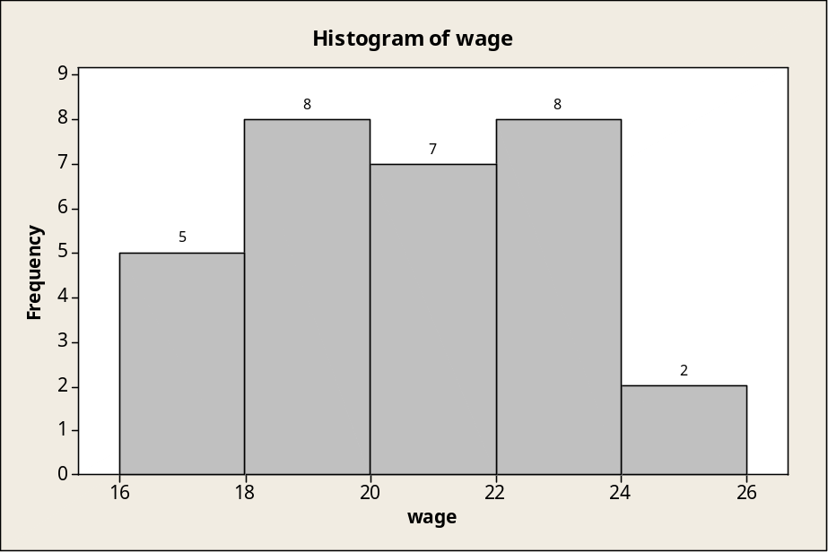

2.10 c/p/m The number of applicants in each category is shown above the corresponding bar.
For example, there were 9 applicants within the 70 – under 80 category.
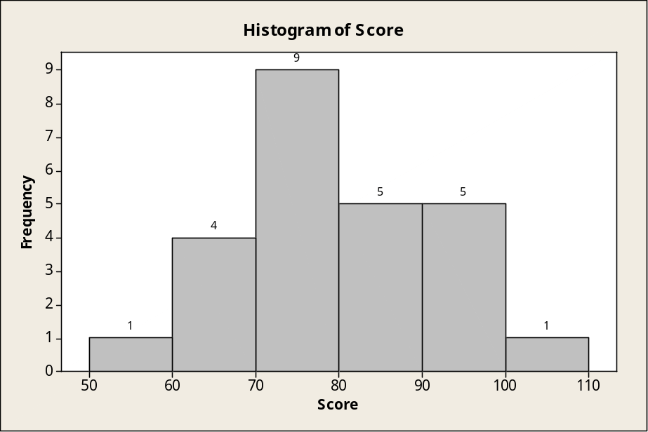

2.11 c/p/m The number of seasons in each goal category is shown above the bars. For example, there were 2 seasons during which Mr. Gretzky’s goal total was in the 70 – under 80 category.
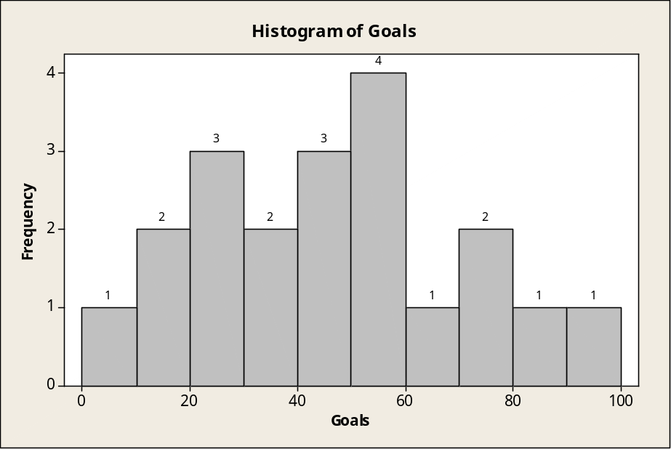

2.12 c/a/m
Annual Sales | Percent | Cumulative Frequency
Under $10,000 | 59.30 | 1262
$ 10,000 - under $ 25,000 | 12.03 | 1518
$ 25,000 - under $ 50,000 | 7.42 | 1676
$ 50,000 - under $ 100,000 | 6.58 | 1816
$ 100,000 - under $ 250,000 | 7.47 | 1975
$ 250,000 - under $500,000 | 3.85 | 2057
$500,000 - under $1,000,000 | 1.97 | 2099
$1,000,000 or more | 1.36 | 2128

2.13 c/a/m
Driver Age | Percent | Cumulative Frequency
Under 20 | 5.29 | 10.72
20- under 25 | 8.31 | 27.56
25 - under 35 | 20.12 | 68.34
35 - under 45 | 22.49 | 113.93
45 - under 55 | 18.10 | 150.63
55 - under 65 | 11.50 | 173.95
65 or older | 14.19 | 202.71

2.14 c/a/m
Total Deposits, $ Billions | Relative Frequency, % | Greater-Than or Within, %
0 - under 100 | 58.0 | 100.0
100 - under 200 | 24.0 | 42.0
200 - under 300 | 8.0 | 18.0
300 - under 400 | 4.0 | 10.0
400 - under 500 | 2.0 | 6.0
500- under 600 | 0.0 | 4.0
600 - under 700 | 0.0 | 4.0
700 – under 800 | 4.0 | 4.0

2.15 c/a/m Less-than Ogive for 50 U.S. States:
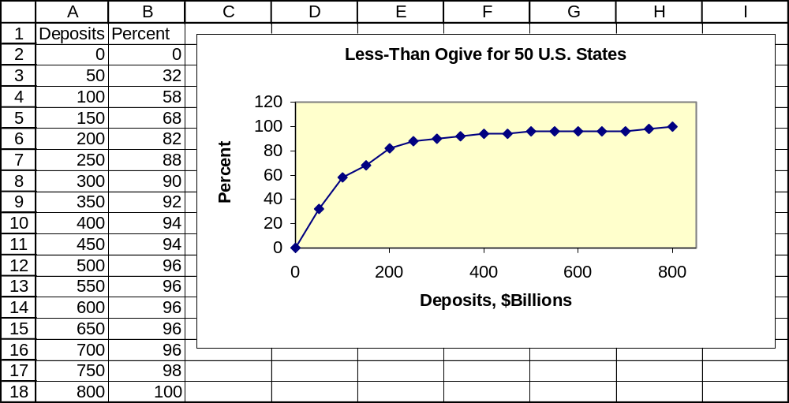

2.16 c/p/m
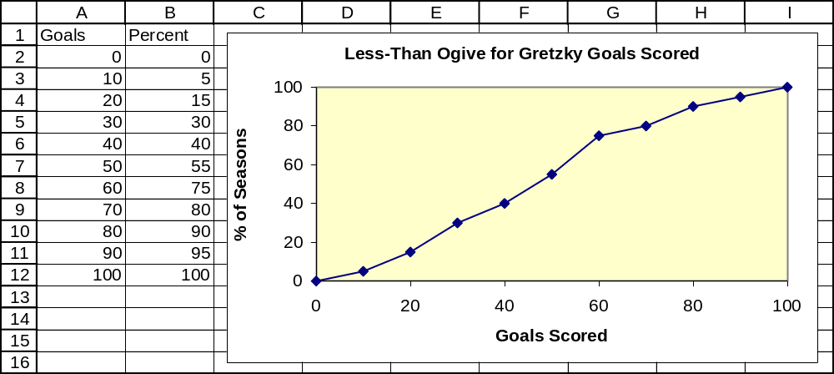

2.17 c/c/m
The number of data values in each category is shown above the bar. For example, there are 10 data values in the $30,000 – under $40,000 category. There are two portfolio values at the extremes that seem especially low or high compared to the others.
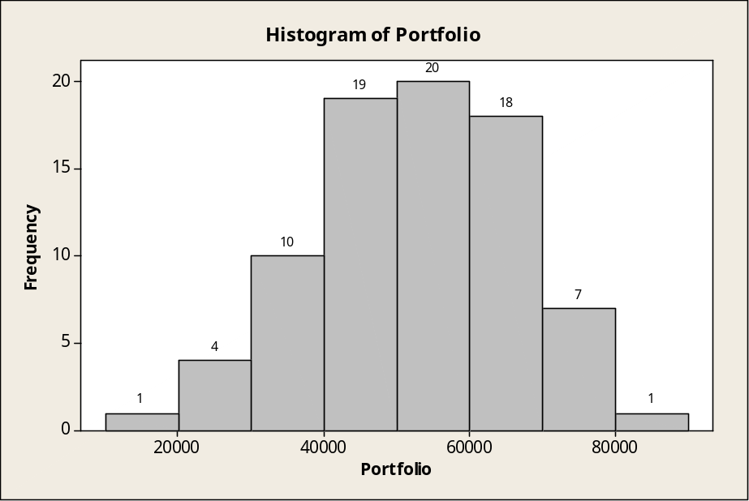

2.18 c/c/m The number of data values in each category is shown above the bar. For example, there was only one data value in the 28 seconds – under 30 seconds category, and this seems to be an especially low time compared to the others.
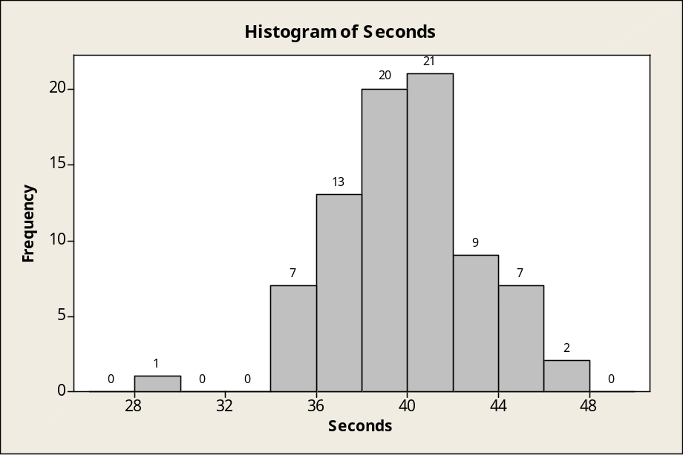

2.19 c/c/m The number of data values in each category is shown above the bar. For example, there are 23 data values in the 55 – under 60 e-mails category. The single values in the 40 – under 45 and 45 – under 50 categories would appear to be especially low compared to the others.
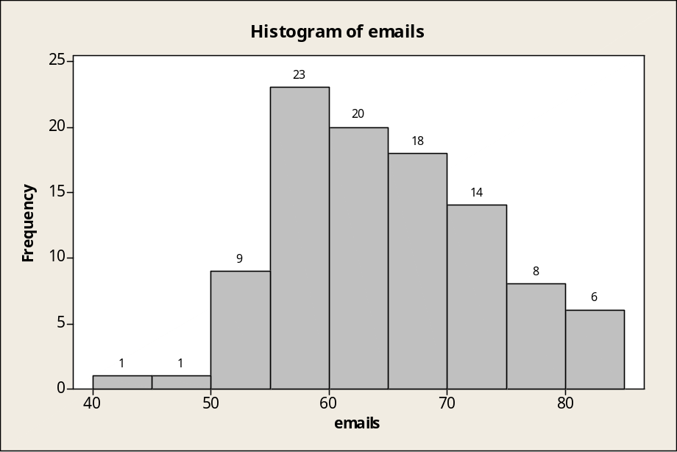

2.20 c/p/m 2.21 c/p/m
Stem (Tens) | Leaf (Units) Stem (Tens) | Leaf (Units)
1 | 559 1 | 13799
2 | 014567 2 | 24446889
3 | 458 3 | 0023379
4 | 12688 4 | 1123366689
5 | 17 5 | 22334677799
6 | 24479 6 | 0113
7 | 1257
8 | 13

2.22 c/p/m
20 20 22 22 27 28 30 31 31 33 35 39 41 43 44 44 54 57

2.23 c/p/d It is not possible to determine the exact values because there is not enough detail to determine the units digit. One possible set of data is shown below:
613 695 770 899 955
630 702 864 900 962
633 708 866 903 981
652 721 884 909
677 755 897 936

2.24 c/c/m
Stem-and-Leaf Display: Portfolio

Stem-and-leaf of Portfoli N = 80
Leaf Unit = 1000
1 1 9
4 2 033
5 2 7
10 3 12234
15 3 66788
25 4 0111222233
34 4 566668899
(9) 5 001133334
37 5 55566777899
26 6 001111222
17 6 677778889
8 7 003334
2 7 6
1 8 0

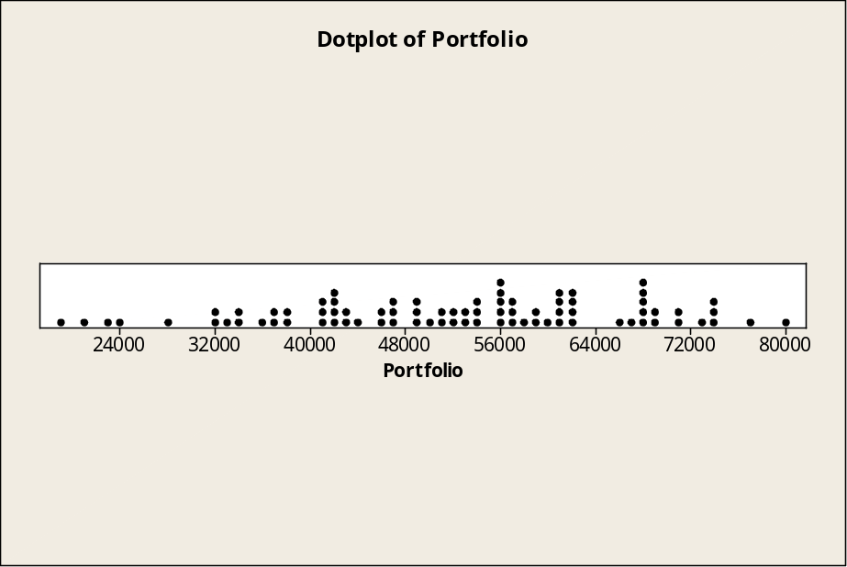

2.25 c/c/m
Stem-and-Leaf Display: Seconds

Stem-and-leaf of Seconds N = 80
Leaf Unit = 0.10
1 29 1
1 30
1 31
1 32
1 33
3 34 79
8 35 45557
12 36 0589
21 37 145677999
29 38 04556689
(12) 39 122344457778
39 40 0112333456789
26 41 00357778
18 42 033359
12 43 135
9 44 22249
4 45 66
2 46 56

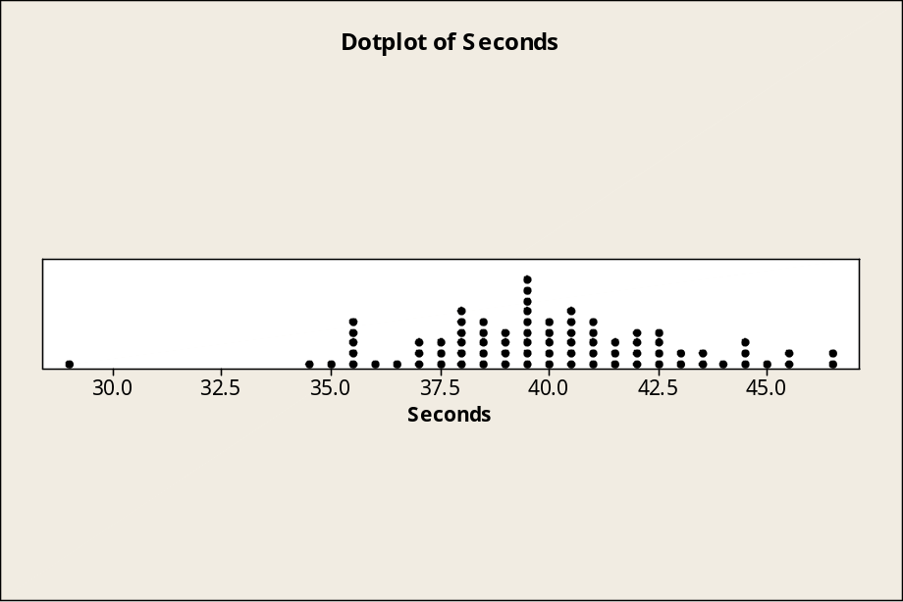

2.26 c/c/m
Stem-and-Leaf Display: emails

Stem-and-leaf of emails N = 100
Leaf Unit = 1.0
1 4 1
2 4 9
11 5 002222344
34 5 55555566778888888999999
(20) 6 00111112223334444444
46 6 555566667777777899
28 7 00001111222244
14 7 55666777
6 8 000134

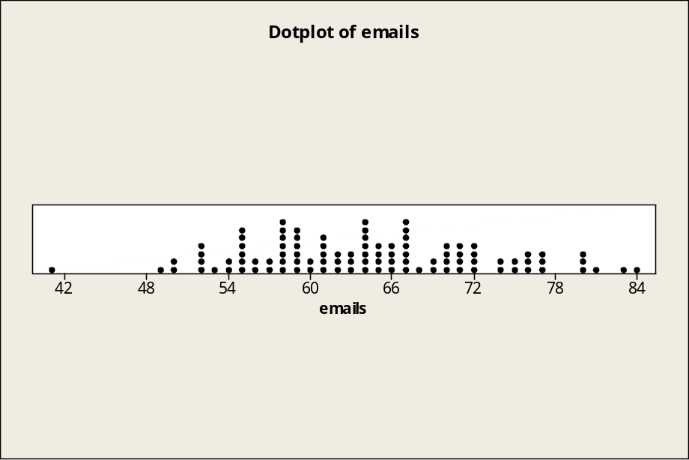

2.27 c/c/m
Stem-and-Leaf Display: Appraisal

Stem-and-leaf of Appraisa N = 60
Leaf Unit = 10
1 2 1
5 2 2233
12 2 4445555
20 2 66666777
25 2 99999
(8) 3 00000001
27 3 22233333
19 3 444455555
10 3 677
7 3 888999
1 4 1

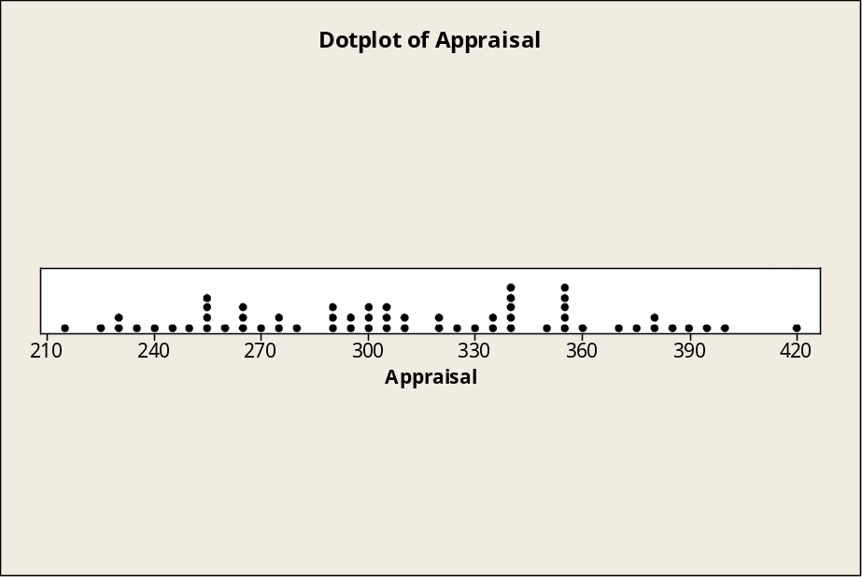

2.28 c/c/m
Stem-and-Leaf Display: meters

Stem-and-leaf of meters N = 80
Leaf Unit = 1.0
2 7 12
7 7 56789
19 8 001111233444
37 8 555556666777889999
(19) 9 0011111222333333344
24 9 5566666678999
11 10 00112344
3 10 78
1 11 2

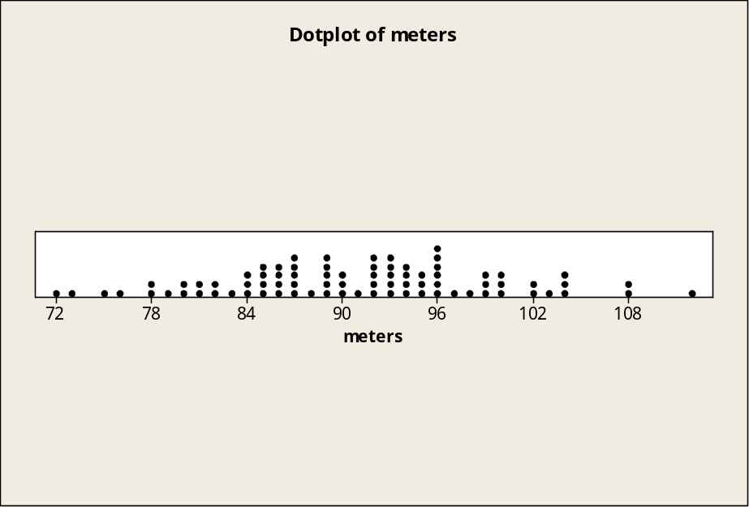

2.29 d/p/m A histogram graphically displays class intervals as well as class frequencies. A bar chart displays the frequencies for a set of categories or classes. Histograms are appropriate for quantitative data, while bar charts are better for qualitative data.

2.30 c/a/m
Bar Chart of market shares in 2007:
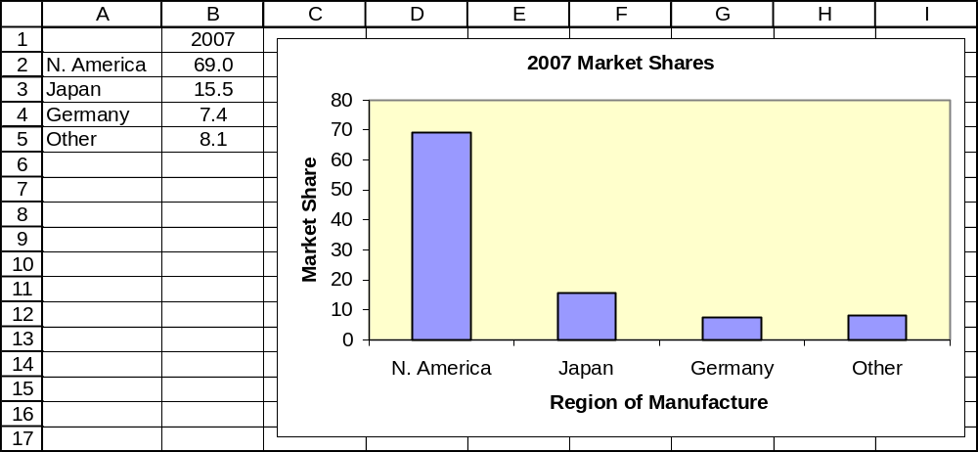

2.31 c/p/m
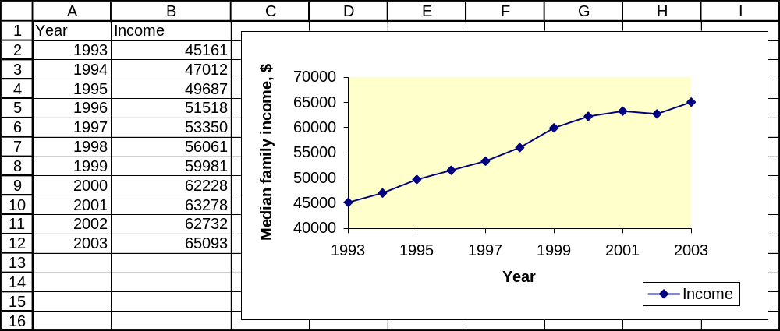

2.32 c/p/m
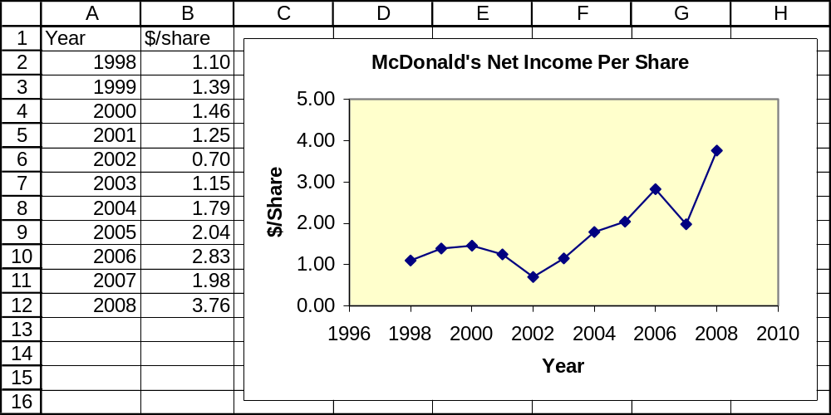

2.33 c/p/m
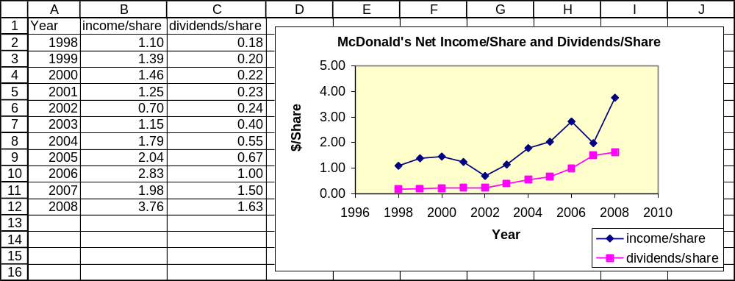

2.34 c/p/m
a. Pie chart summarizing Campbell Soup Foundation contributions:
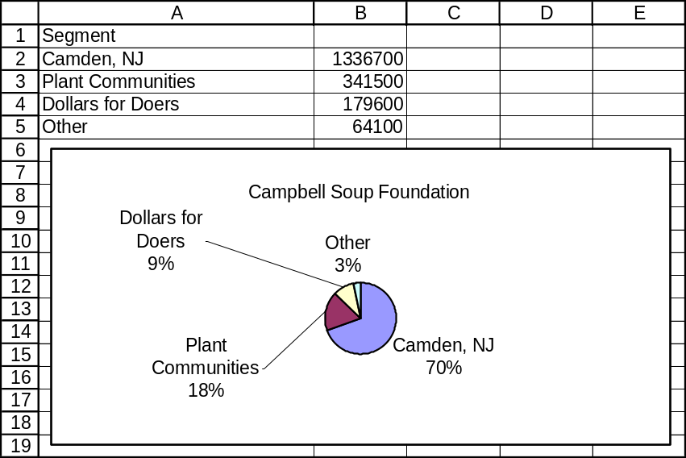

b. Bar chart summarizing Campbell Soup Foundation contributions:
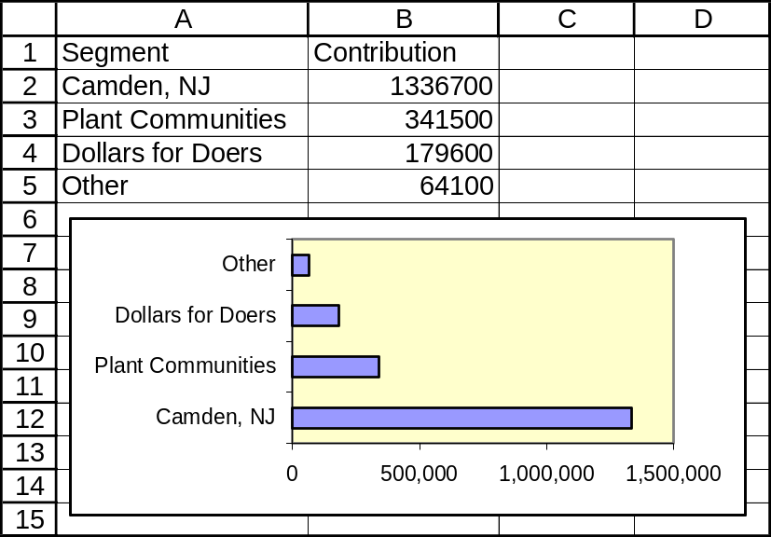

c. A bar chart is appropriate because the data are qualitative.

2.35 c/p/d
a. Ownership of a telephone and subscription to cable TV are two different variables, not mutually exclusive categories.
b. Pie Charts.
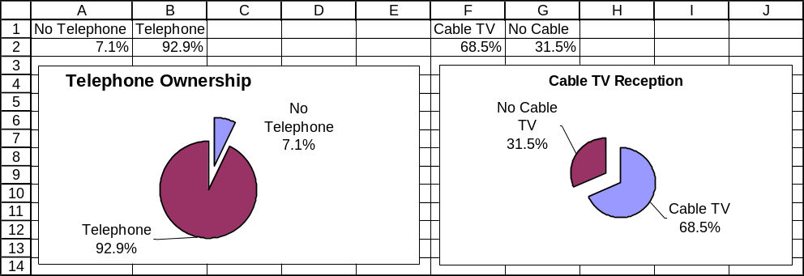

2.36 c/p/m
a. Pictogram using flags; each flag represents approximately $100 billion in defense expenditures:
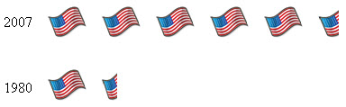

b. Pictogram with stacks of money; each stack representing about $100 billion in defense expenditures.
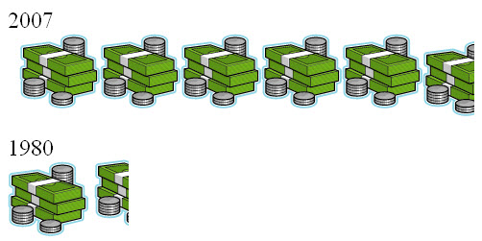

2.37 c/a/m The ship representing 2007 is approximately 4.1 (i.e., 553/134) times as high, 4.1 times as wide, and will have about 17 times the area of the ship representing 1980.


1980 2007

2.38 d/p/e A scatterplot is a plot in which each point represents a pair of known or observed values of x and y. The variables are represented on the horizontal (x) and vertical (y) axes. The scatterplot is useful in examining whether the variables might be related to each other in some way.

2.39 d/p/e In a positive linear relationship, y tends to increase linearly with increases in x. In a negative linear relationship, y tends to decrease linearly as x increases.

2.40 d/p/e When there is no relationship between two variables, the slope of the best-fit straight line will tend to be zero.

2.41 p/p/m We can use Excel to plot the data for us. As we can see from the graph, there does appear to be a very slight direct relationship between the variables – printers with a higher speed for printing text also tend to have a higher speed for printing graphics. Note: The line in the graph below was actually fitted by Excel. Lines "eyeballed" by humans may vary.
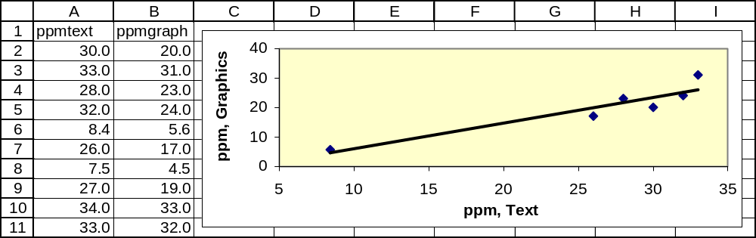

2.42 p/p/m We can use Excel to plot the data for us. As we can see from the graph, there does appear to be a strong linear relationship between service revenues and expenses for supplies. The relationship appears to be a direct relationship; that is, as revenues increase, supply expenses increase. Note: The line in the graph below was actually fitted by Excel. Lines "eyeballed" by humans may vary.
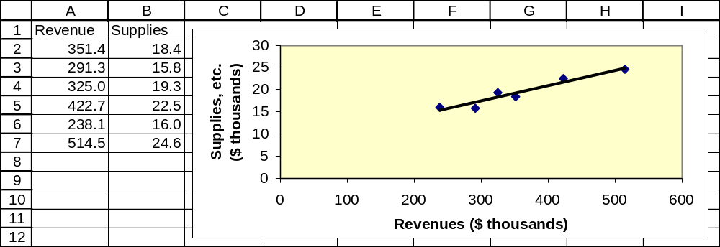

2.43 p/p/m
We can use Excel to plot the data for us. As can be seen from the graph, there could be a very weak direct relationship between the amount of bailout received and the added cash cushion that is needed. However, this line seems to be influenced a lot by the one company that got $45.0 billion in bailout money and still needed $33.9 billion in the form of an added cash cushion. If it were not for that one company, the fitted line might even end up having a negative slope. The line in the graph below was fitted by Excel, and lines "eyeballed" by humans may vary.
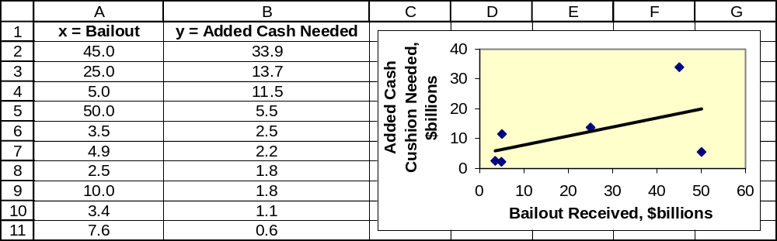

2.44 p/c/m
a. Scatter diagram with best-fit linear equation:
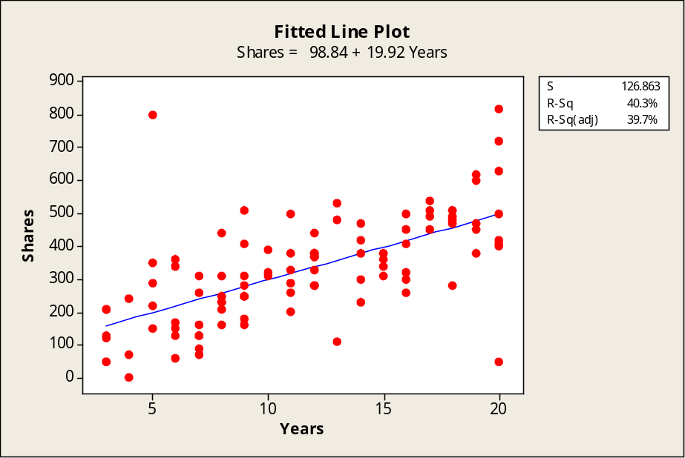

b. There appears to be a direct relationship between the variables. Employees who have been with the company for more years tend to own more shares of stock.
c. The slope of the equation is +19.92. Each additional year with the company tends to be accompanied by an additional 19.92 shares of stock.
d. One person who has been with the company for only five years owns an unusually large amount of stock (800 shares) for a person with his relatively short tenure with the company.
Two other individuals, one with 13 years of service and the other with 20 years of service, own unusually small amounts of stock considering how long they have been with the company.

2.45 p/c/m
a. Scatter diagram with best-fit linear equation:
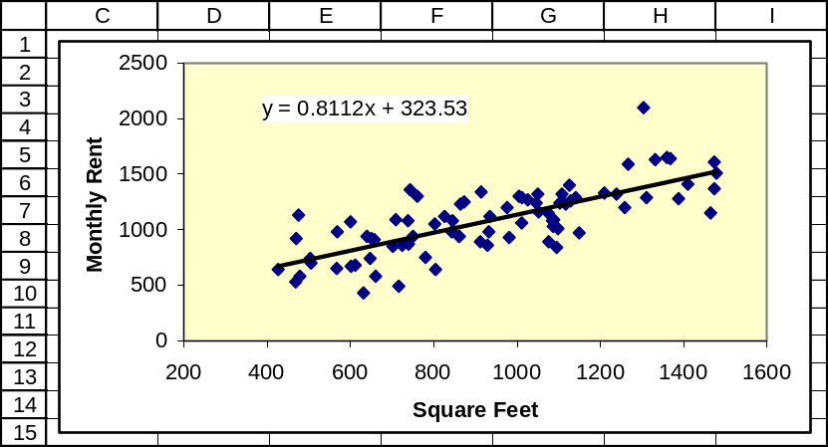
b. There appears to be a direct relationship between the variables. Apartments with more square feet of living area tend to have a higher monthly rental fee.
c. The slope of the equation is +0.8112. Each additional square foot of living area tends to be accompanied by an additional $0.8112 in monthly rental fee.
d. One of the apartments appears to have about 1300 square feet of living space, but the rent is relatively high (over $2000) for an apartment of this size. The location may be very attractive.

2.46 d/p/e The classificatory variables that represent the rows and columns of the contingency table will be in the nominal scale of measurement. The variables described within the table can be nominal (categories) when counts are being expressed. They can be interval or ratio when measures such as the median or mean are being expressed.

2.47 d/p/e Simple tabulation involves just one variable – e.g., we may express a count of how many persons in a sample are males and how many are females. In cross tabulation, we express a count of how many people are in combinations of categories – e.g., how many males are in the under-21 age group, how many females are in the 21-40 age group, and so on.

2.48 c/p/e
a. Simple tabulation. There are 17 vehicles with a Diesel engine, 13 with a gasoline engine.

Tabulated Statistics: Engine

Rows: Engine

Count

1 17
2 13
All 30

b. Cross tabulation – e.g., there are 9 vehicles that have a Diesel engine and manual transmission.

Tabulated Statistics: Engine, Trans

Rows: Engine Columns: Trans

1 2 All

1 9 8 17
2 6 7 13
All 15 15 30

Cell Contents --
Count

c. Average mpg according to type of engine and type of transmission – e.g., the average fuel economy for the 9 vehicles having a Diesel engine and manual transmission is 36.789 miles per gallon.
Diesel engines get a higher mpg than gasoline engines (33.918 versus 22.085) and manual transmissions get a higher mpg than automatics (31.633 versus 25.947). The most efficient combination is the Diesel engine with manual transmission.

Tabulated Statistics: Engine, Trans

Rows: Engine Columns: Trans

1 2 All

1 9 8 17
36.789 30.688 33.918

2 6 7 13
23.900 20.529 22.085

All 15 15 30
31.633 25.947 28.790

Cell Contents --
Count
mpg:Mean

2.49 c/p/e
a. Simple tabulation. There are 17 vehicles with a Diesel engine, 13 with a gasoline engine.

Tabulated Statistics: Engine

Rows: Engine

Count

1 17
2 13
All 30

b. Cross tabulation – e.g., there are 9 vehicles that have a Diesel engine and air conditioning.

Tabulated Statistics: Engine, AC

Rows: Engine Columns: AC

1 2 All

1 8 9 17
2 5 8 13
All 13 17 30

Cell Contents --
Count

c. Average mpg according to type of engine and whether the vehicle has air conditioning – e.g., average fuel economy for the 9 vehicles having a Diesel engine and air conditioning is 32.089 miles per gallon. Diesel engines get a higher mpg than gasoline engines (33.918 versus 22.085) and cars without air conditioning get a higher mpg than cars with air conditioning (31.731 versus 26.541).
The most efficient combination is the Diesel engine without air conditioning.

Tabulated Statistics: Engine, AC

Rows: Engine Columns: AC

1 2 All

1 8 9 17
35.975 32.089 33.918

2 5 8 13
24.940 20.300 22.085

All 13 17 30
31.731 26.541 28.790

Cell Contents --
Count
mpg:Mean

2.50 c/p/e
a. Simple tabulation. There are 15 vehicles with a manual transmission, 15 with an automatic.

Tabulated Statistics: Trans

Rows: Trans

Count

1 15
2 15
All 30

b. Cross tabulation – e.g., there are 7 vehicles that have a manual transmission and air conditioning.

Tabulated Statistics: Trans, AC

Rows: Trans Columns: AC

1 2 All

1 8 7 15
2 5 10 15
All 13 17 30

Cell Contents --
Count

c. Average mpg according to type of transmission and whether the vehicle has air conditioning – e.g., average fuel economy for the 8 vehicles having a manual transmission and no air conditioning is 33.538 miles per gallon. Cars with manual transmissions get a higher mpg than cars with automatic transmissions (31.633 versus 25.947) and cars without air conditioning get a higher mpg than cars with air conditioning (31.731 versus 26.541). The most efficient combination is the manual transmission without air conditioning.

Tabulated Statistics: Trans, AC

Rows: Trans Columns: AC

1 2 All

1 8 7 15
33.538 29.457 31.633

2 5 10 15
28.840 24.500 25.947

All 13 17 30
31.731 26.541 28.790

Cell Contents --
Count
mpg:Mean

2.51 c/c/m
a. Simple tabulation. Among the 60 schools, 25 offer the bachelors as the highest degree, 24 offer the masters degree as their highest degree, and 11 offer doctorate degrees.
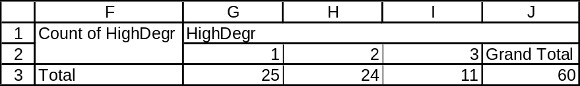

b. Cross tabulation – e.g., 13 of the 60 schools are privately supported and offer the bachelors degree as their highest degree.
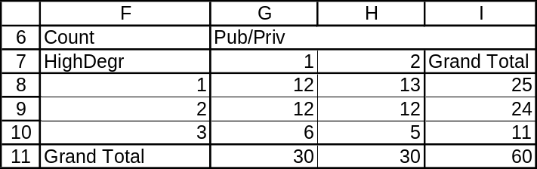

c. Average tuition and fees according to highest degree offered and public versus private support – e.g., for publicly supported schools that offer the bachelors as the highest degree, the average for tuition and fees is $5323. Private schools that offer a doctorate degree average $16,092 in tuition and fees. There seems to be a strong relationship between the categorization variables and the amount for tuition and fees.
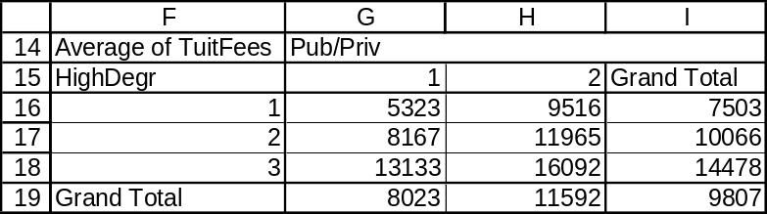

2.52 c/c/m
a. Simple tabulation. Among the 60 schools, 19 are in an urban setting, 26 are in a suburban setting, and 15 are in a rural setting.
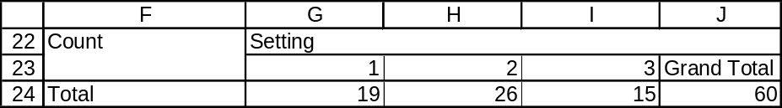

b. Cross tabulation – e.g., 15 of the 60 schools are publicly supported and located in a suburban setting.
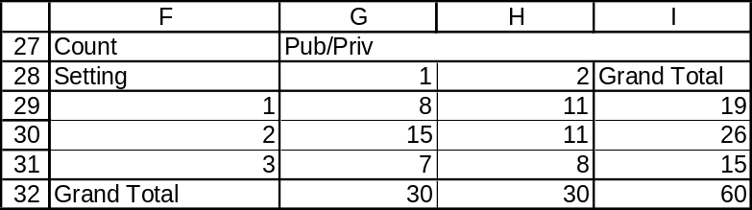

c. Average tuition and fees according to campus setting and public versus private support – e.g., for publicly supported schools in a rural setting, the average for tuition and fees is $5960. Private schools in an urban setting average $12,668 in tuition and fees. There seems to be a strong relationship between the categorization variables and the amount for tuition and fees.
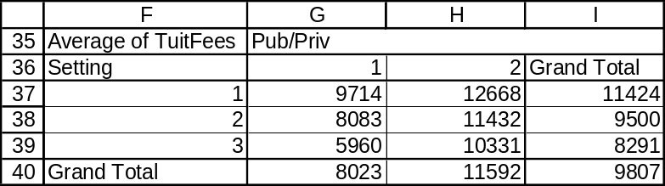

2.53 c/c/m
a. Simple tabulation. Among the 35 cities, 3 received a grade of “2” on financial management,
27 received a “3”, and 5 received a “4”.
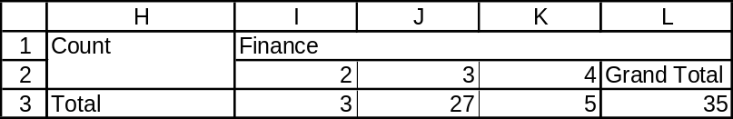

b. Cross tabulation – e.g., 13 of the 35 cities received a “3” on financial management and a “2” on information technology.
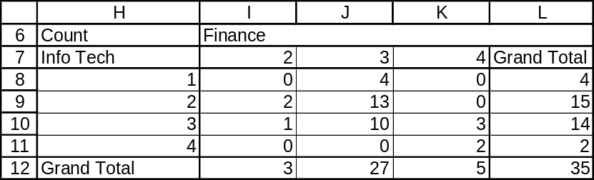

c. Average population according to grades on financial management and information technology. Cities receiving a “2” on each measure have an average population of 277,257. Cities receiving a “4” on each measure were more than twice as large, with an average population of 676,347. There does seem to be some relationship between the population and the grades received. In general, it seems that larger cities tended to receive higher grades on these measures.
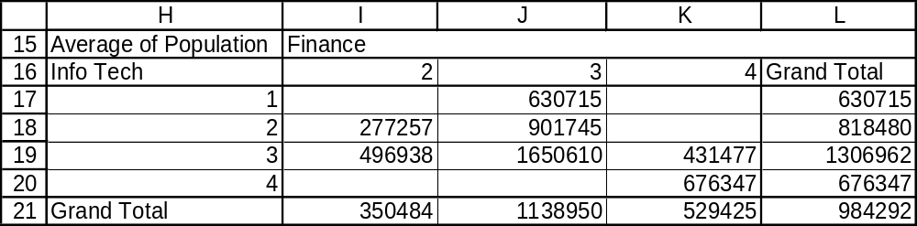

2.54 c/c/m
a. Simple tabulation. Among the 35 cities, 1 received a grade of “0” on personnel policies, 2 received a “1”, 16 received a “2”, 13 received a “3”, and 3 received a “4”.
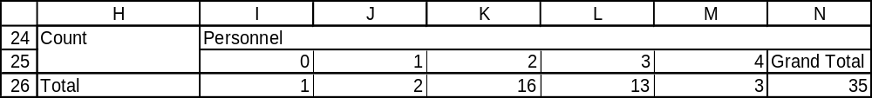

b. Cross tabulation – e.g., 8 of the 35 cities received a “2” on personnel policies and a “3” on managing for results.
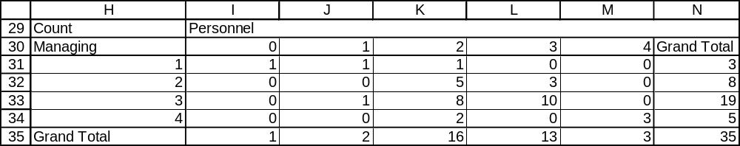

c. Average population according to grades on personnel policies and managing for results. Cities receiving a “1” on each measure have an average population of 328,175. Cities receiving a “3” on each measure were more than four times as large, with an average population of 1,346,951.
There does seem to be some relationship between the population and the grades received. In general,
it seems that larger cities tended to receive higher grades on these measures. However, this trend appears to reverse for very high scores on the measures. For example, cities receiving a “4” on each of these measures had a smaller average population (729,203) than those receiving a “3” on each measure.
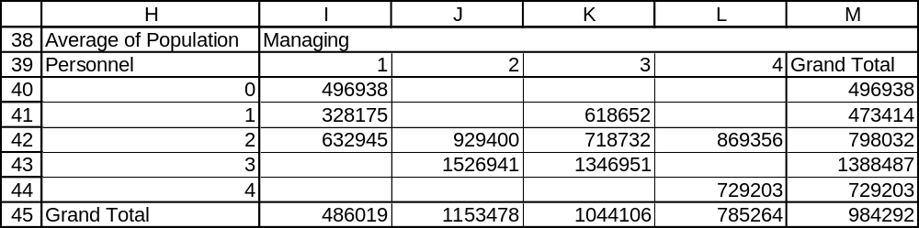

CHAPTER EXERCISES
2.55 c/a/m
a. 1342 cities b. 2815 cities c. 253 cities; 8.77% d. 175,000
e. Relative frequency distribution:
population | percent
10,000 - under 25,000 | 52.32
25,000 - under 50,000 | 23.70
50,000 - under 100,000 | 14.90
100,000 - under 250,000 | 6.62
250,000 - under 500,000 | 1.28
500,000 - under 1,000,000 | 0.87
1,000,000 or more | 0.31

2.56 c/a/m
a. Stem-and-leaf display.

Stem-and-Leaf Display: Temp

Stem-and-leaf of Temp N = 50
Leaf Unit = 1.0

1 9 0
1 9
2 9 5
3 9 7
5 9 89
8 10 001
16 10 22222333
(12) 10 444444445555
22 10 6667777777
12 10 889
9 11 00011
4 11 23
2 11 4
1 11
1 11
1 12
1 12 2

b. and c. Frequency distribution, interval widths, and class marks.
class | frequency | class mark | class width
90 - under 95 | 1 | 92.5 | 5
95 - under 100 | 4 | 97.5 | 5
100 - under 105 | 19 | 102.5 | 5
105 - under 110 | 17 | 107.5 | 5
110 - under 115 | 8 | 112.5 | 5
115 - under 120 | 0 | 117.5 | 5
120 - under 125 | 1 | 122.5 | 5

d. Minitab histogram and Excel relative frequency polygon.
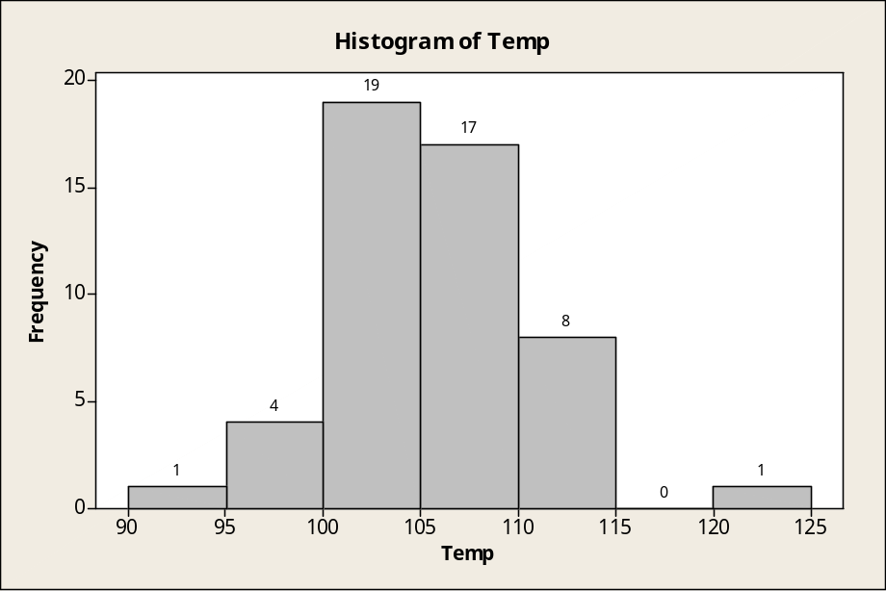

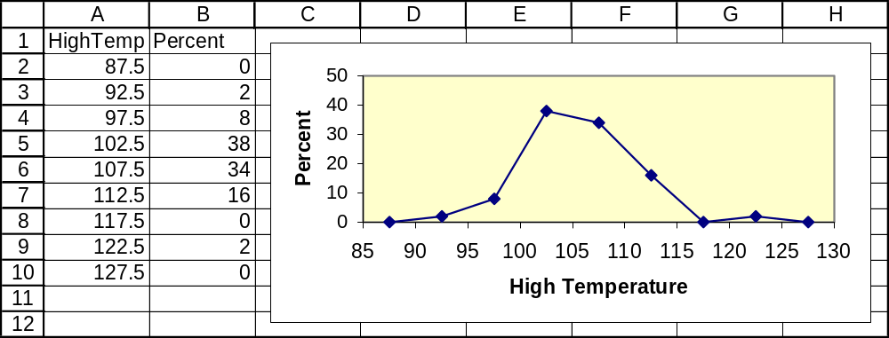

2.57 c/a/m
a. Stem-and-leaf display.

Stem-and-Leaf Display: Cost

Stem-and-leaf of Cost N = 50
Leaf Unit = 100

1 0 7
4 0 999
9 1 01111
20 1 22233333333
(6) 1 445555
24 1 666666667777
12 1 8888999
5 2 00
3 2 22
1 2 4

b. and c. Frequency distribution, interval widths, and class marks.
class | frequency | class mark | class width
600 - under 800 | 1 | 700 | 200
800 - under 1000 | 3 | 900 | 200
1000 - under 1200 | 5 | 1100 | 200
1200 - under 1400 | 11 | 1300 | 200
1400 - under 1600 | 6 | 1500 | 200
1600 - under 1800 | 12 | 1700 | 200
1800 - under 2000 | 7 | 1900 | 200
2000 - under 2200 | 2 | 2100 | 200
2200 - under 2400 | 2 | 2300 | 200
2400 - under 2600 | 1 | 2500 | 200

d. Minitab histogram and Excel relative frequency polygon.
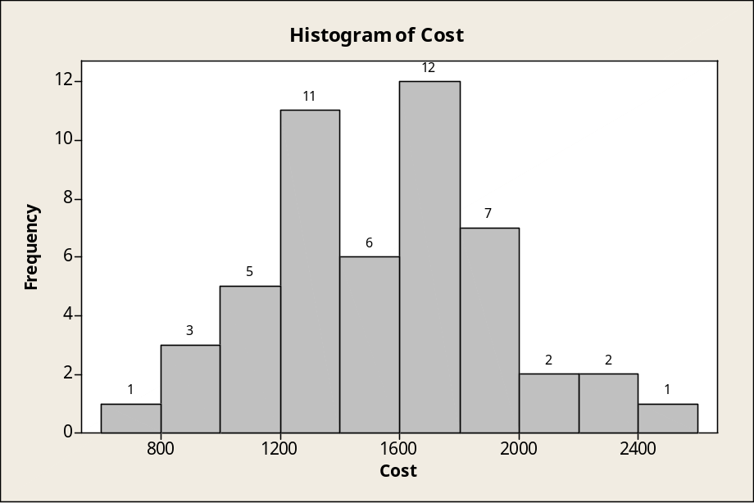

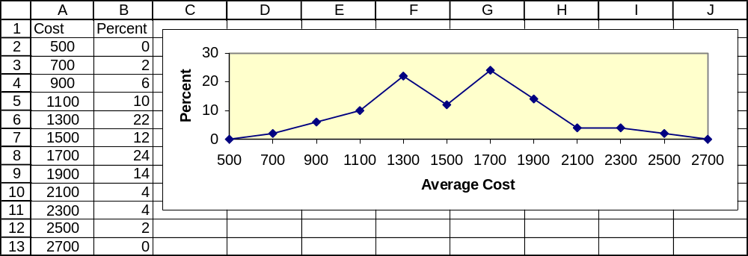

2.58 c/a/m
b. Stem-and-leaf display.

Stem-and-Leaf Display: Unemp%

Stem-and-leaf of Unemp% N = 50
Leaf Unit = 0.10

4 2 6999
8 3 0112
16 3 56667779
(10) 4 0011233334
24 4 556666666679
12 5 001234
6 5 666
3 6 12
1 6
1 7 1

c. and d. Frequency distribution.
class | frequency | class mark | class width
2.0 - under 3.0 | 4 | 2.5 | 1.0
3.0 - under 4.0 | 12 | 3.5 | 1.0
4.0 - under 5.0 | 22 | 4.5 | 1.0
5.0 - under 6.0 | 9 | 5.5 | 1.0
6.0 - under 7.0 | 2 | 6.5 | 1.0
7.0 - under 8.0 | 1 | 7.5 | 1.0

e. Minitab histogram and Excel relative frequency polygon.
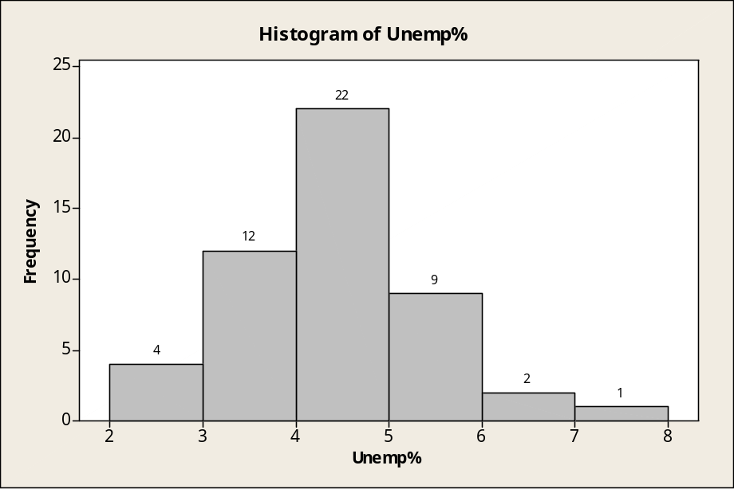

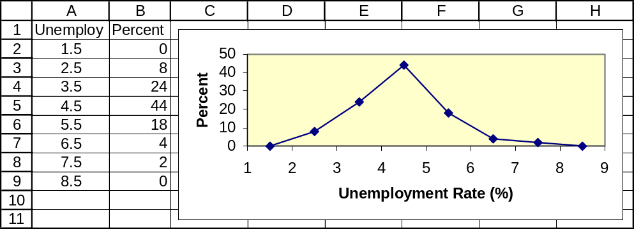

2.59 c/a/m
Homes in the West Region seem to be more expensive.
Price of Home in $ 1000 units | Total U.S. % | West Region %
Under 200 | 34.58 | 12.15
200 - under 300 | 29.29 | 29.83
300 - under 500 | 24.00 | 35.36
500 or over | 12.13 | 22.65

2.60 c/p/d
a. 33 36 36 39 45 46 46 47 50 51 52 52 53 53 56 58 60 67 67 69 70
b. The left-most column shows the number of values in that stem or lower-value stems for values less than 50, or the number of values in that stem or higher-value stems for values greater than 54.
The number (6) indicates there are six values in the stem for 50-54 and the median is in that stem.

2.61 c/p/d
a. No. 185 192 207 240 246 250 251 256 259 289 296 305
308 313 314 320 336 342 353 356 381
b. The left-most column shows the number of values in that stem or lower-value stems for values less than 280, or the number of values in that stem or higher-value stems for values greater than 299.
The number (2) indicates there are two values in the stem for 280-299 and the median is in that stem.

2.62 c/p/m The Excel chart seems very weak in its support of the claim that increases in advertising tend to be accompanied by increases in sales. However, even if there were a stronger level of support, it would not necessarily prove that increases in advertising cause increases in sales. Actually, companies often allocate advertising budgets as a percentage of either actual or anticipated sales. The wide scale of the vertical axis, combined with the great disparity between annual amounts for sales and advertising, tends to make the advertising/promotion increases a little more difficult to notice here.
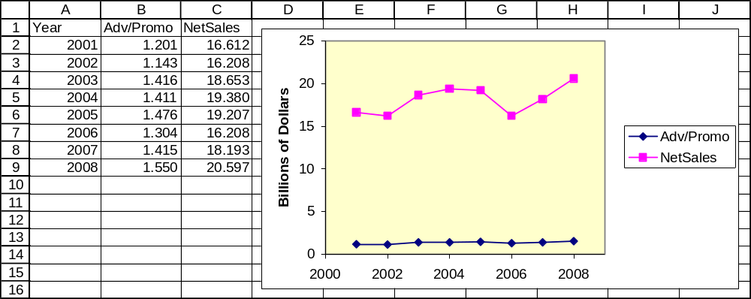

2.63 d/p/m Guns, human figures wielding knives, and coffins are some of the possible symbols that would tend to convey a negative image.

2.64 c/c/m Phoenix, AZ (122 degrees) is an outlier at the high end, Juneau, AK (90 degrees) at the low end.
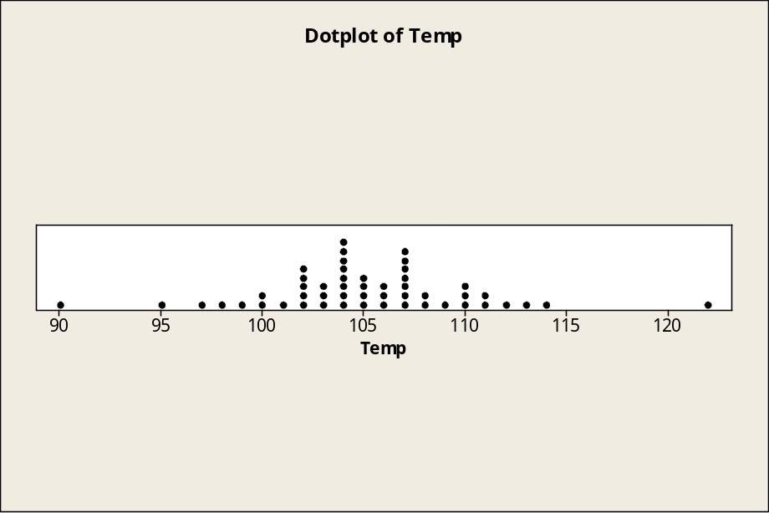

2.65 c/c/m Alaska ($2455) has the highest average cost, and Washington ($2298) and Oregon ($2202) are not too far below. All three of these states are distinctively above the remainder of the states. South Dakota ($774) stands out by a noticeable margin as the lowest-cost state.
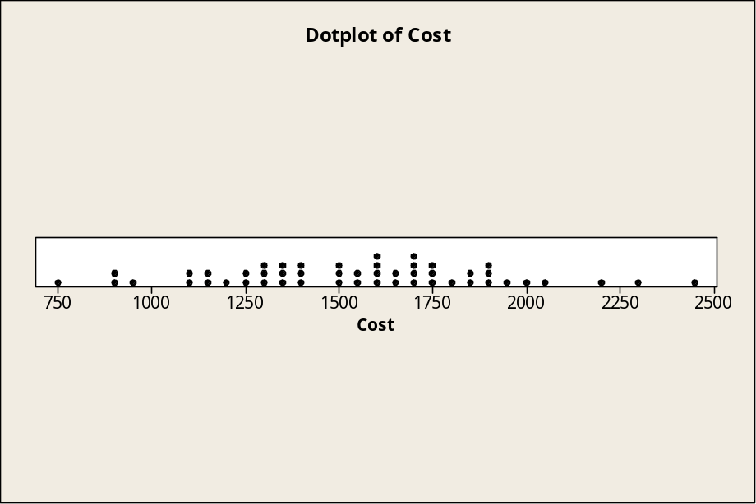

2.66 c/c/m It is apparent that the 2007 percentages are shifted considerably to the left compared to the 1980 data. For 2007, there also seem to be fewer outliers at the high end than in the 1980 period.
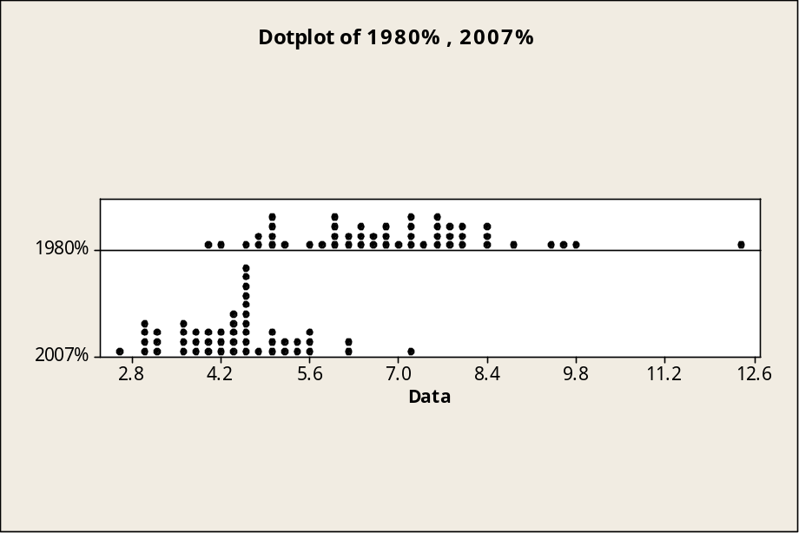

2.67 c/c/m
a. Considering only the scatter diagram, the schools given higher scores by the academicians tend to receive higher scores from the lawyers/judges as well.
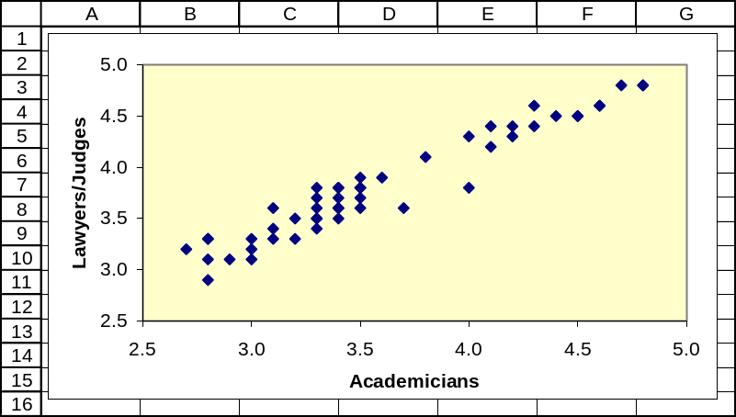

b. The slope of the fitted equation is positive, reflecting the same observation made in part (a).
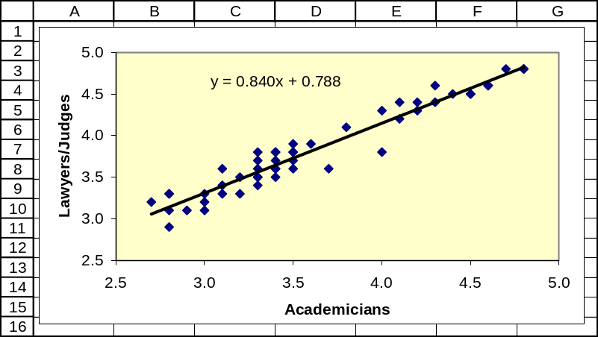

2.68 c/c/m The scatter diagram and fitted equation are shown together.
a. Considering the points in the scatter diagram, it is obvious that schools rated higher by lawyers and judges tend to produce graduates who are more likely to be employed upon graduation.
b. The fitted linear equation has a positive slope and supports this observation.
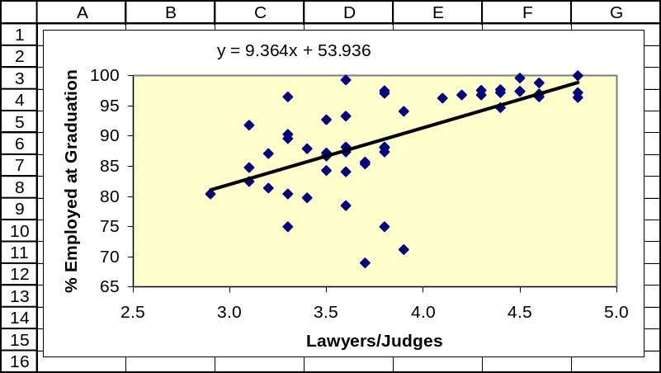

2.69 c/c/m The scatter diagram and fitted equation are shown together.
a. If we consider only the points in the scatter diagram, it is obvious that higher U.S. saving rates tend to be accompanied by higher saving rates in Canada.
b. The fitted linear equation has a positive slope and supports this observation
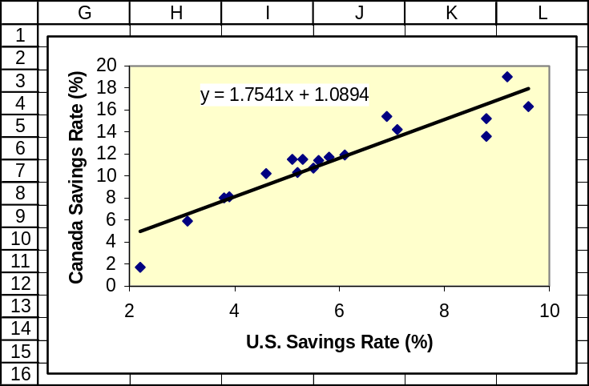

2.70 c/c/m The scatter diagram and fitted equation are shown together.
a. If we consider only the points in the scatter diagram, higher saving rates in the U.S. would appear to be accompanied by higher saving rates in Germany, but the relationship might be curvilinear rather than linear. As U.S. rates go from approximately 6% to approximately 9%, the rates in Germany decrease, then begin to increase again.
b. The fitted linear equation is not a very good fit, but it has a positive slope and supports the observation made in part (a).
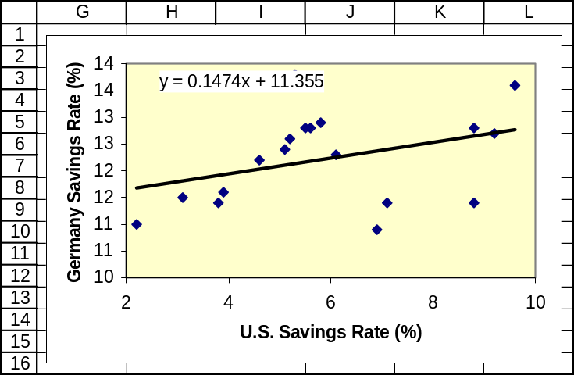

2.71 c/c/m
a. Mechanical supplier 1 supplied the mechanical components for 50 of the air compressors and mechanical supplier 2 provided the mechanical components for the other 50.
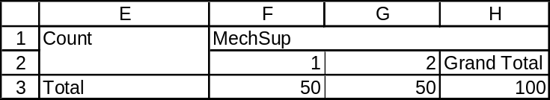

b. Crosstab showing how many compressors had each combination of mechanical supplier and electrical supplier.
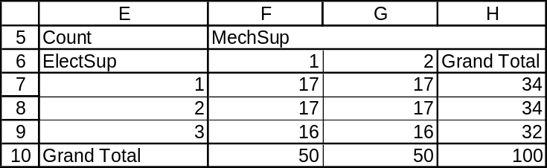

c. Table showing average pressure (psi) for each combination of mechanical supplier and electrical supplier. Compressors associated with mechanical supplier 2 and electrical supplier 1 had the highest average pressure (408.74). Those associated with mechanical supplier 1 and electrical supplier 3 had the lowest average pressure (388.11).
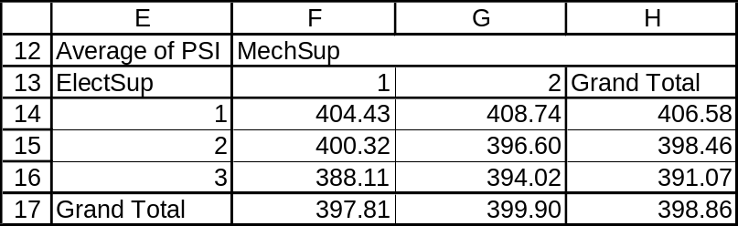

d. Overall, the compressors associated with electrical supplier 3 had an average pressure of only 391.07 psi. Regardless of which mechanical supplier was involved, compressors associated with electrical supplier 3 had the lowest average output. For electrical supplier 3, note the 388.11 psi average when associated with mechanical supplier 1 and the 394.02 psi average when associated with mechanical supplier 2.

2.72 c/c/m
a. Electrical supplier 1 supplied the electrical components for 34 of the air compressors. Electrical suppliers 2 and 3 provided the electrical components for 34 and 32 compressors, respectively.
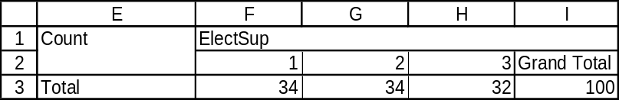

b. Crosstab showing how many compressors had each combination of electrical supplier and final assembly technician.
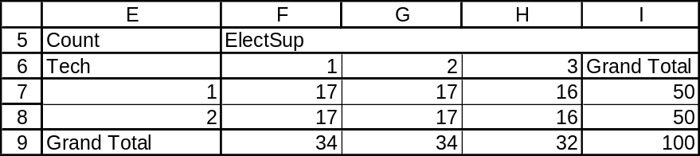

c. Table showing average pressure (psi) for each combination of electrical supplier and final assembly technician. Compressors associated with electrical supplier 1 and final assembly technician 2 had the highest average pressure (408.47). Those associated with electrical supplier 3 and final assembly technician 1 had the lowest average pressure (387.53).
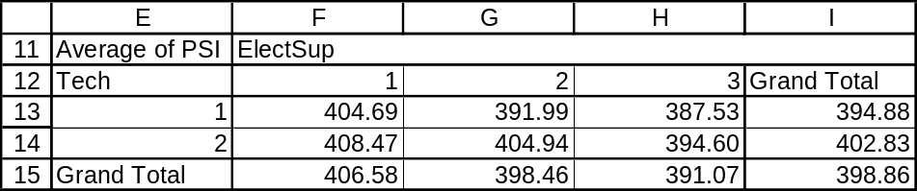

d. Overall, the compressors associated with final assembly technician 1 had an average pressure of only 394.88 psi. Regardless of which electrical supplier was involved, compressors associated with final assembly technician 1 had a lower average output than those associated with the other technician.
For final assembly technician 1, note the 404.69 psi average when associated with electrical supplier 1, the 391.99 psi average when associated with electrical supplier 2, and the 387.53 psi average when associated with electrical supplier 3.

INTEGRATED CASES

THORNDIKE SPORTS EQUIPMENT (ALSO SEE THORNDIKE VIDEO UNIT ONE)

1. and 2. Minitab histograms describing the frequency distributions for the distances traveled by the new and the conventional golf ball types – e.g., for the new ball, there are 5 observations in the "250-under 260" class and 1 observation in the "290-under 300" class.
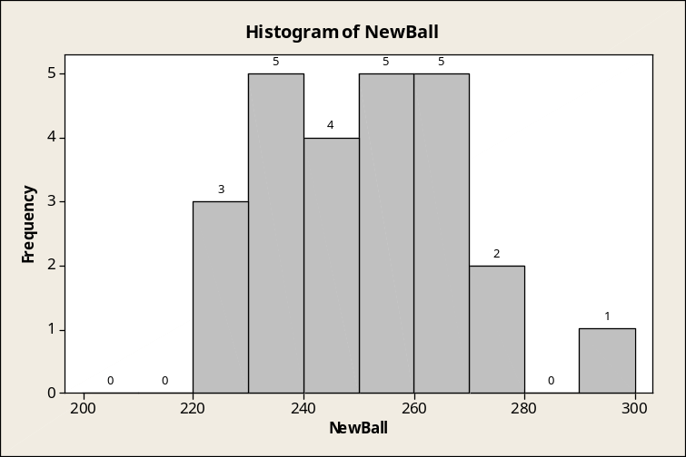

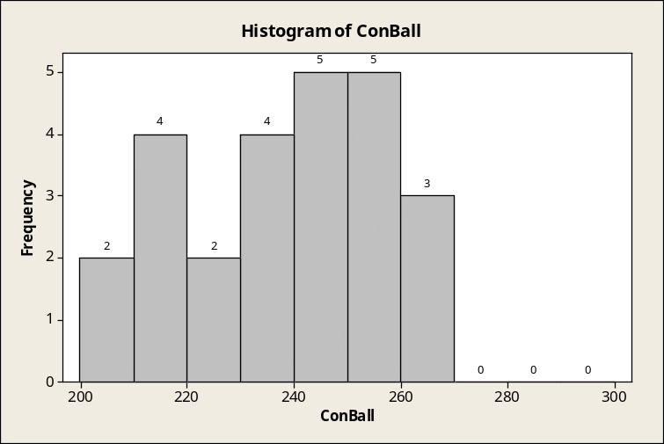

3. The distance traveled by the new golf ball has a tendency to be greater than for the conventional ball.

SPRINGDALE SHOPPING SURVEY

This exercise is based on SHOPPING, the Springdale shopping survey database. There are 30 variables and 150 cases (respondents) in this database. This solution relies on Minitab.

1. Frequency distributions (Minitab histograms with center points) for variables 7, 8, and 9. Respondents tend to like Springdale Mall the most and West Mall the least.
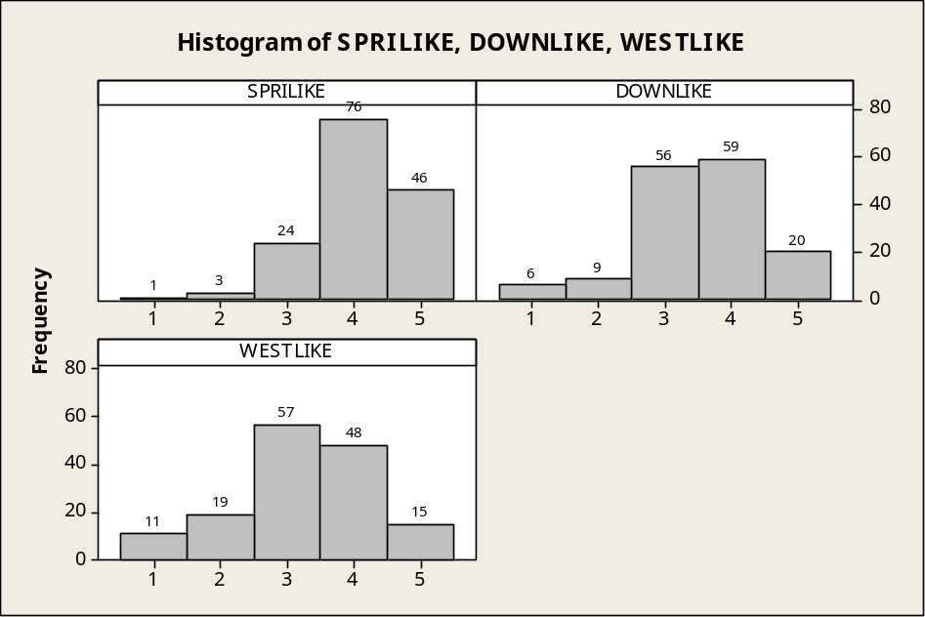

2. Construction/comparison of frequency distributions for variables 4, 5, and 6.
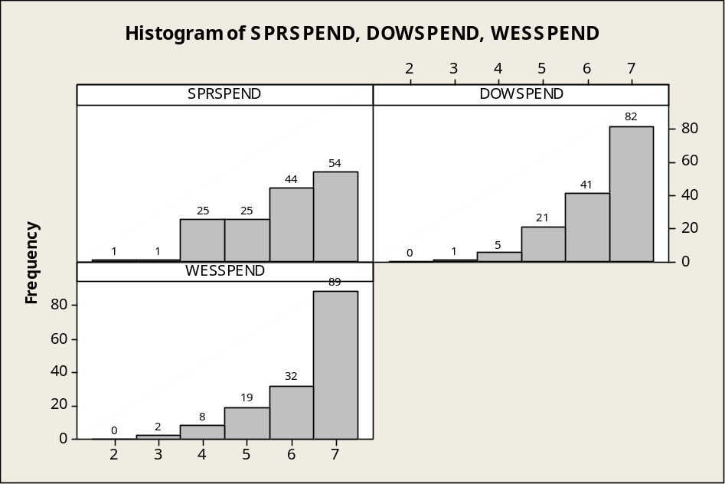
Respondents tend to be more frugal during visits to West Mall and Downtown, and least frugal on visits to Springdale Mall. Of the 150 respondents, 121 spend under $25 (categories 6 and 7) during a typical visit to West Mall, with 123 persons in these categories for Downtown and 98 for Springdale Mall.

3. "Best-fit" scores for the shopping areas on variables 10 through 17.
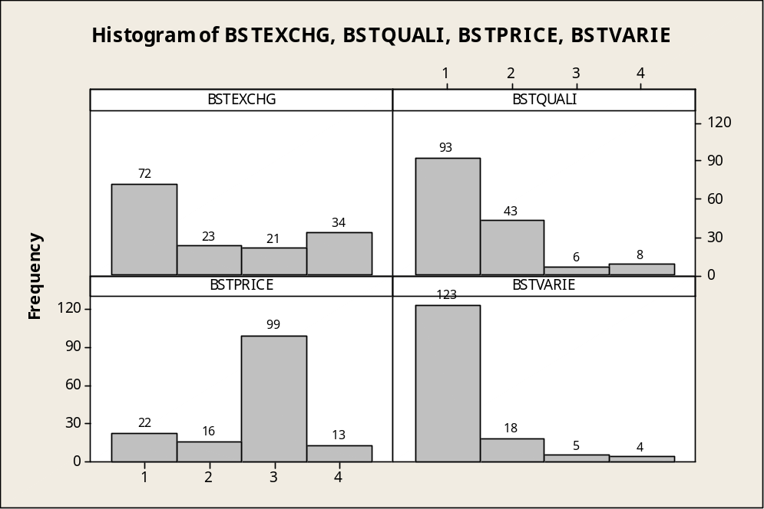
Springdale Mall is viewed as the best area for returning/exchanging merchandise, West Mall is seen as being the worst.
Springdale Mall is seen as having the highest quality goods, with Downtown coming in second.
West Mall is strongly perceived as the best shopping area for low prices.
Springdale Mall is seen as having the best variety of goods, with each of the other areas far behind.

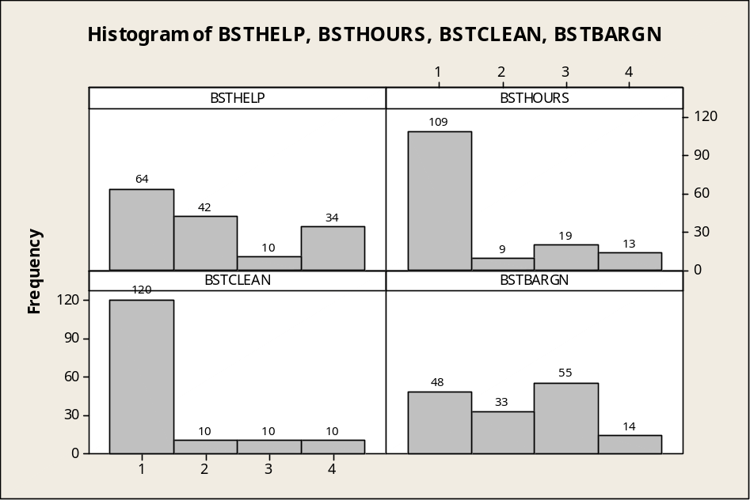
Springdale Mall is viewed as having the most helpful/friendly sales personnel.
Springdale Mall is far ahead in having the most convenient shopping hours.
Springdale Mall is viewed as having the cleanest stores and surroundings.
West Mall is the "bargain mall," most highly seen as having a lot of bargain sales.

4. Crosstab using categorization variables 26 (gender) and variable 28 (marital status), with cells showing the average for variable 30 (respondent age).

Rows: RESPGEND Columns: RESPMARI

1 2 All

1 24 34 58
44.750 27.647 34.724

2 43 49 92
34.791 26.490 30.370

All 67 83 150
38.358 26.964 32.053

Cell Contents --
Count
RESPAGE:Mean

The 24 males (RESPGEND = 1) who are married (RESPMARI = 1) have the highest average age, 44.750 years. The youngest respondents are the unmarried females, with an average age of 26.490 years.
The average age for all respondents is 32.053 years.

